JavaScript Basics : Functions

# Section 5 - Default Parameters

There are times that we want to supply default values to the parameters of a function.

Here we have a function for calculating interest:

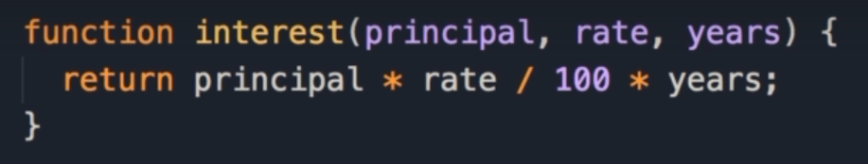

The function takes 3 parameters, principal (amount), interest rate and years.

The formula to calculate total interest is: principal * rate / 100 * years

When we call the function, we pass in 10000 for the principal, 3.5 as the interest rate, and we are paying this back over 5 years.

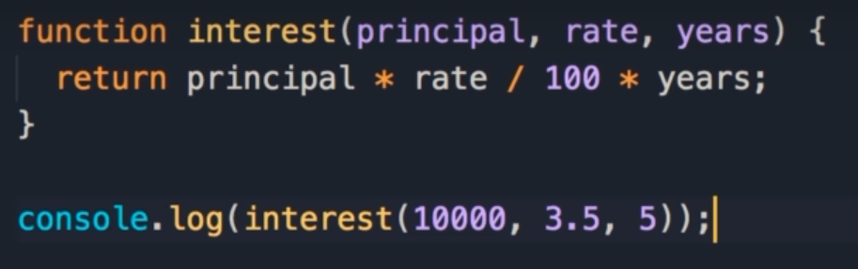

In our console, we see that the total interest we have to pay back is 1750.



## Default Values

Here we supply default values for interest rate and number of years.

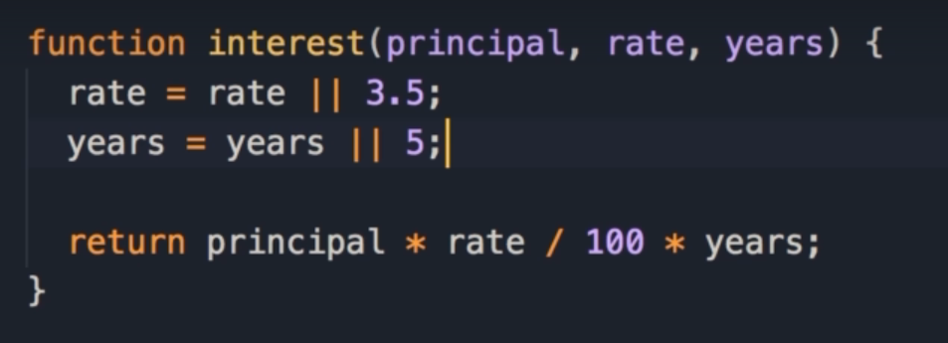

In the section about operators, we learnt about the technique using OR (||)

rate = rate || 3.5;

So if rate has a truthy value, use that, else use 3.5

We can use the logical or operator to give variables a default value.

With this, if we exclude these arguments, those default values will be used.

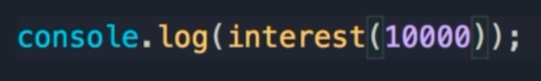



## Easier Default Parameters

Starting from ES6, we have a cleaner and easier way to do this, by setting the default values when declaring the parameters themselves.

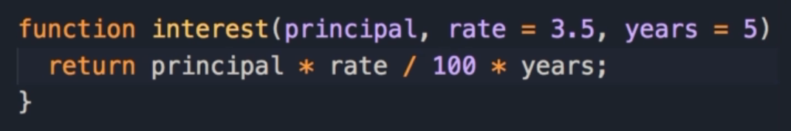

So we set rate to 3.5 and years to 5



The results in our log show the total interest correctly.



As you can see, setting default parameters is easy.

## Default Value Conventions

One convention that you must follow, is that once you give a parameter a default value, you should also give all the other parameters after that a default value.

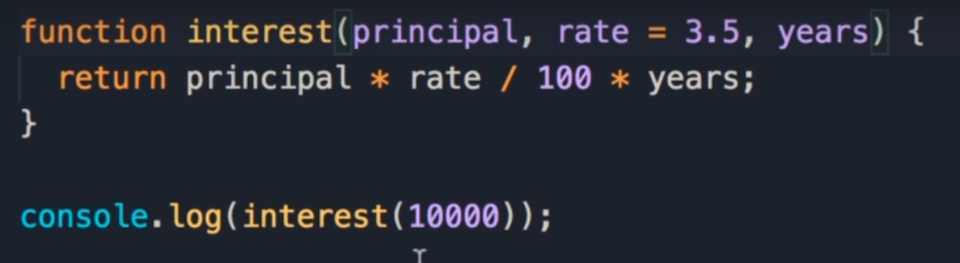

Here we set the default value for rate, but not for years.

When we log this, we get Not a Number, because we pass 10,000, so principal is 10,000, rate is by default 3.5, but years doesn't have a value, so it's undefined.



That’s why the result is Not a Number

## Default Value Confusion

Here we attempt to pass 5 for the years.

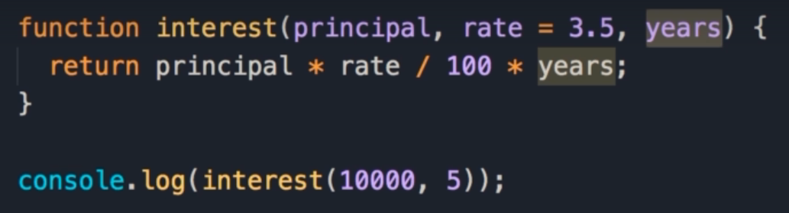

This is confusing for the JavaScript engine because it doesn't know if 5 should be used for rate or the years.

In our console we get the same result: Not a Number.



This is because in this case 5 is used for the rate, but years is still undefined.

## Passing Undefined

There is a trick around this, we can pass undefined for the second parameter, and with this, rate will be set to 3.5 and years will be set to 5.

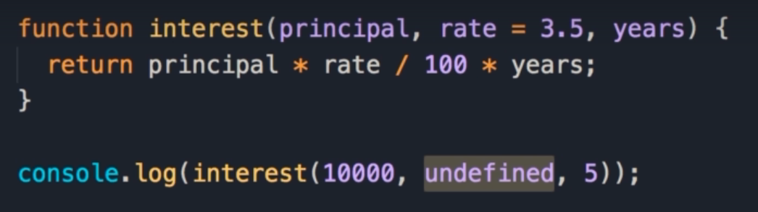

Now our console shows we get the same answer.



But code like this is really ugly.

Somebody looking at this code, they wonder, what is this undefined?

They have to look at the function to figure out what parameter is associated with undefined.

So as a best practice, whenever you want to give the function parameter a default value, make sure that that parameter is the last parameter in the list, or give all the parameters after that a default value.

1. Area of a Circle  
   Create a circle object using the object literal syntax
   1. This object should have a radius property that we can read an write to
      1. Eg. circle.radius = 2;
   2. An area property that is read only. We should not be able to set the area from the outside, but we should be able to read it
      1. Eg. console.log(circle.area);
      2. The formula to calculate area of a circle: area = Pi * radius * radius